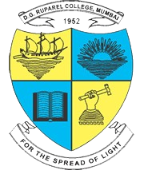
Modern Education Society’s
The D. G. Ruparel College of Arts, Science & Commerce,
senapati bapat marg, opp. Matunga road station (w.r.), mahim, mumbai 400 016

Department of Computer Science

CERTIFICATE
Mr. Rane Anil Arun.
This is to certify that Mr./Ms. ___________________________________________,
Seat no:________________ of T.Y.B.Sc. (Sem V) class has satisfactorily completed the Mini Project __________________________ __________________________, to be submitted in the partial fulfillment for the award of Bachelor of Science in Computer Science during the academic year 2026 – 2027.
Android Application to Manage the Tasks

Date of Submission:

Project Guide Head / Incharge,
Department Computer Science

College Seal Signature of Examiner

